Transportation Careers

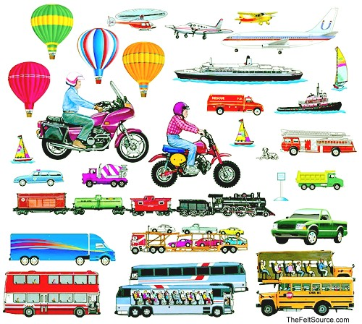

# Lake Career & Technical Center

P.O. Box 1409

Camdenton, MO 65020

Phone (573)346-9260

Fax (573)346-9284

Instructor- Mr. Tim Keeney

[tkeeney@camdentonschools.org](mailto:tkeeney@camdentonschools.org)

**Transportation Careers**

Instructor - Mr. [Tim Keeney](http://camdentonschools.schoolwires.net/site/Default.aspx?PageID=2093)

Transportation Careers will allow students to learn the basics of automobile construction, tools of the trade, and vehicle maintenance. This class will cover, in depth, the careers available in the transportation field. Transportation Careers will also cover the history of the automobile along with other modes of transportation and the importance it plays in our culture. Students will have hands-on opportunities to detail and perform minor cosmetic repairs on project vehicles. Job seeking and acquisition skills will be covered. Technology, math, and communication skills are incorporated into the class.

Transportation Careers Expectations

Each member of the class will follow the Lake Career & Technical Center Handbook rules. The handbook is the basis for all classes at the school. However, each program is different in the way that it operates; therefore, these are additional expectations.

1. Please respect all individuals in the classroom.
2. Please follow directions the first time they are given.
3. Students should take notes during lecture and actively participate in class discussions.
4. As a responsible student, you are expected to finish any project that you begin.
5. Please raise your hand to be recognized in class before speaking during instructional and test time.
6. Safety glasses must be worn in the lab area at all times.
7. Only soft soled tennis shoes or work shoes can be allowed in the lab area.
8. As you are now young adults please act that way accordingly.
9. Please do not toss or throw objects to other students.
10. If you are absent from school, please contact me before or after school upon your return for any missed assignments.
11. Please return all tools and equipment to proper storage area when not in use.
12. Ask permission before leaving the classroom or lab area. (Hall pass required)
13. Please be courteous when working around other student’s tools or projects.

**Power Standards**

**TC – Transportation Careers**

**1. Safety**

TC1a Shop Safety

TC1b Tool/Equipment Safety

**2. Specialized Procedures**

TC2a Service Literature

TC2b Parts Lookup

**3. Automotive**

TC3a Maintenance

TC3b Basic systems

**4. Marine**

TC4a Maintenance

TC4b Basic systems

**5. Motorcycle**

TC5a Maintenance

TC5b Basic systems

**6. Pre-Employment**

PE1a Application

PE1b Resume

**7. Work Ethics**

WE1a Scoring Guide (Attendance, Time Management, Ethical Behavior, Personal Responsibility, and Interpersonal Skills)